**Project Planning Phase**

**Project Planning Template (Product Backlog, Sprint Planning, Stories, Story points)**

|  |  |
| --- | --- |
| Date | 18 November 2022 |
| Team ID | PNT2022TMID26125 |
| Project Name | Inventory Management System for Retailers |
| Maximum Marks | 8 Marks |

**Product Backlog, Sprint Schedule, and Estimation (4 Marks)**

|  |  |  |  |  |  |
| --- | --- | --- | --- | --- | --- |
| **Sprint** | **Functional**  **Requirement**  **(Epic)** | **User**  **Story**  **Number** | **User Story / Task** | **Priority** | **Team Members** |
| Sprint 1 | Registration | USN-1 | As a user, I can register for the application by entering my email, password, and confirming my password. | High | Split between all 4 |
| Sprint 1 |  | USN-2 | As a user, I will receive confirmation email once I have registered for the application | Medium | Split between all 4 |
| Sprint 1 | Login | USN-3 | As a user, I can log into the application by entering email & password | High | VITHYA T |
| Sprint 2 | Items | USN-5 | As a user, I can add the items. | High | REYAN A |
| Sprint 2 |  | USN-6 | As a user, I can see the items | Low | PRIYANKA B |
| Sprint 2 | Inventory | USN-7 | As a user, I can add the items to inventory. | High | VITHYA T |
| Sprint 2 |  | USN-8 | As a user, I can see the items in the inventory. | Low | PRIYANKA B |
| Sprint 3 | Indication | USN-9 | As a user, I can be able to receive indication | High | REYAN A |
| Sprint 3 | Location | USN-10 | As a user, I can be able to see items from a particular store location | Medium | VIJAYALAKSHMI R |
| Sprint 3 |  | USN-11 | As a user, I can add a new location of my store | Medium | VIJAYALAKSHMI R |
| Sprint 4 | Purchase | USN -12 | As a customer, I can be able to purchase good from the particular location of the store | High | REYAN A |
| **Sprint** | **Functional**  **Requirement**  **(Epic)** | **User**  **Story**  **Number** | **User Story / Task** | **Priority** | **Team Members** |
| Sprint 4 | Deployment | USN-13 | As a user, I can access the software in the web | High | VITHYA T |

|  |  |  |  |  |  |  |
| --- | --- | --- | --- | --- | --- | --- |
| **Sprint** | **Total Story Points** | **Duration** | **Sprint Start Date** | **Sprint End Date (Planned)** | **Story Points**  **Completed (as on**  **Planned End Date)** | **Sprint Release Date (Actual)** |
| Sprint-1 | 20 | 7 Days | 24 Oct 2022 | 30 Oct 2022 | 20 | 30 Oct 2022 |
| Sprint-2 | 20 | 7 Days | 31 Oct 2022 | 06 Nov 2022 | 20 | 07 Nov 2022 |
| Sprint-3 | 20 | 7 Days | 07 Nov 2022 | 14 Nov 2022 | 20 | 14 Nov 2022 |
| Sprint-4 | 20 | 7 Days | 14 Nov 2022 | 21 Nov 2022 | 20 | 21 Nov 2022 |

**Project Tracker, Velocity & Burndown Chart: (4 Marks)**

**Velocity:**

Imagine we have a 10-day sprint duration, and the velocity of the team is 20 (points per sprint). Let’s calculate the team’s average velocity (AV) per iteration unit (story points per day)

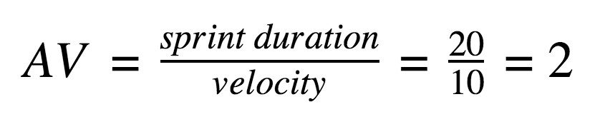

|  |  |  |  |  |  |
| --- | --- | --- | --- | --- | --- |
| **Sprint** |  | **Total Story Points** |  | **Duration** | **Average Velocity** |
| **Sprint 1** | **20** |  | **7 Days** |  | **20 / 7 = 2.85** |
| **Sprint 2** | **20** |  | **7 Days** |  | **20 / 7 = 2.85** |
| **Sprint 3** | **20** |  | **7 Days** |  | **20 / 7 = 2.85** |
| **Sprint 4** | **20** |  | **7 Days** |  | **20 / 7 = 2.85** |
| **Total** | **80** |  | **28** |  | **80 / 28 = 2.85** |